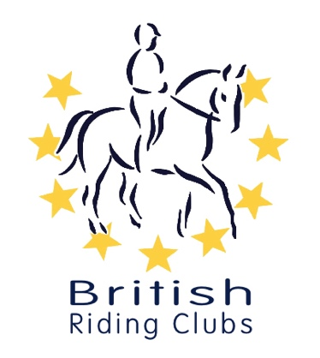
British Riding Clubs – Area 2.
Ivesley Equestrian Centre. Ivesley Lane. Waterhouses. DH7 9HB
On Sunday 24th May 2026
UNAFFILIATED HT COMPETITION
Run under BRC rules


Closing date:5.p.m. 10th May 2025 Late entries £10 extra

Prizes 1st. £80.00, payable if for 4 or more class entries 2nd. £45.00 if more than 10 class entries
3rd - £30.00 payable if more than 15 class entries, payable through BACS

2nd. £45.00 3rd - £30.00 payable through BACS

Class Name | Test | Entry Fee
- Junior/Senior HT 70 Individual | BE90 Dressage 91 (2009) | £80.00
- Junior/Senior HT 80 Individual | BE90 Dressage 92 (2009) | £80.00
- Junior/Senior HT 90 Individual | BE90 Dressage 95 (2012) | £80.00
- Junior/Senior HT 100 Individual | BE100 Dressage 101 (2009) | £80.00

Entries via Equoevents
Organiser Hilary McKenna Email address hilary.mckenna243@gmail.com
Numbers to be printed by competitor, Template on www.ridingclubresults.co.uk
Times will be on www.britishridingclubsarea2.co.uk by 22nd May 2026

This competition will run under British Riding Club Rules. It is important that all competitors are aware of the rules relating to this competition – please see the current BRC Handbook and also the BRC Rule Amendments and Changes Document which can be found at the link below: http://www.bhs.org.uk/enjoy-riding/british-riding-clubs/brc-rulebook

Hats
All hats must have a visible aqua BRC hat tag in place before they are used for warming up and competing, to show that it meets the current safety standards. There will be a trained official available on the day to do this for you if your hat does not currently have one. For up to date hat rules please see the current BRC Handbook.

Body Protectors
A body protector is obligatory in all cross-country competitions and is strongly recommended in show jumping competitions. A BETA Level 3 displaying Blue 2018 label must be worn. Body protectors should be fitted and worn as per the manufacturer’s instructions. The up to date BETA list of body protectors can be obtained from www.beta-uk.org.

Riders wearing Exo Body Cage with a 2000 purple label will be permitted. The competitor must inform the secretary at all events.

Medical armbands
Medical armbands are MANDATORY for any type of cross-country competition. These must be worn on the arm and not on the leg. They should be filled in with the relevant competitor’s details. Checks will be carried out in the collecting ring.

Flu Vaccinations & Microchips
Your horse must have up to date influenza vaccinations in line with rule G7 in the current BRC Handbook.Please take time to check your eligibility as the rules changed in 2024.
There is also a downloadable flu vac checking spreadsheet available to check the flu vaccination: BRC Downloads | The British Horse Society (bhs.org.uk) under ‘Competitions’.
Passports must be presented to the secretary for checking at each competition prior to competing.
)
NO HORSE MAY COMPETE IN ANY BRC COMPETITIONS WITHIN 6 DAYS OF A FLU INJECTION.

