
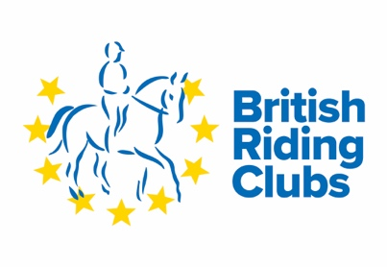
British Riding Clubs
NAF Area Dressage Qualifier
For the BRC National Championships 5th & 6th September 2026
Ivesley Equestrian Centre. Ivesley Lane. Waterhouses. DH7 9HB
21st June 2026
Closing date 5th June 2026

Class | Tests | Entry Fee
1 | Junior/ Senior Team Dressage Grassroots  BD Intro 1 (2024)  BD Intro 2 (2024)  BRC Prelim A (2025)  BRC Prelim B (2025 | £72.00
2. | Junior / Senior Individual Intro Dressage. Grassroots  BD Intro 1 (2024)  BD Intro 2 (2024)  BRC Prelim A (2025)  BRC Prelim B (2025 | £18.00
3 | Junior/Senior Prelim Dressage Team Intermediate  BD Intro 3 (2024)  BD Prelim 1 (2024)  BD Prelim 2 (2024)  BD Nov 1. | £72.00
4 | Junior/Senior Prelim Dressage Individual Intermediate  BD Intro 3 (2024)  BD Prelim 1 (2024)  BD Prelim 2 (2024)  BD Nov 1. | £18.00
5 | Mixed Open Dressage Team  BD Prelim 3 (2024)  BD Novice 2 (2024)  BD Novice 3 (2024)  BD Elementary 1 (2024) | £72.00
6 | Mixed Open Dressage Individual  BD Prelim 3 (2024)  BD Novice 2 (2024)  BD Novice 3 (2024)  BD Elementary 1 (2024) | £18.00
7 | Pick a Test Medium Dressage  BD Medium 4 (2024) or  BD Advanced Medium 4 (2024) | £18.00
8 | Mixed Pairs.  BRC Pairs Test 5 (2018) | £18.00
9 | Summer Veteran Horse BD Prelim 1 (2024) or BD Novice 1 (2024 | £18:00
10 | ) Summer Veteran Rider BD Prelim 2 (2024) or BD Novice 2 (2024) | £18:00

